

Illuminator™ System
Series Supernova
1.75 kW – 16.7 kW
Users Manual
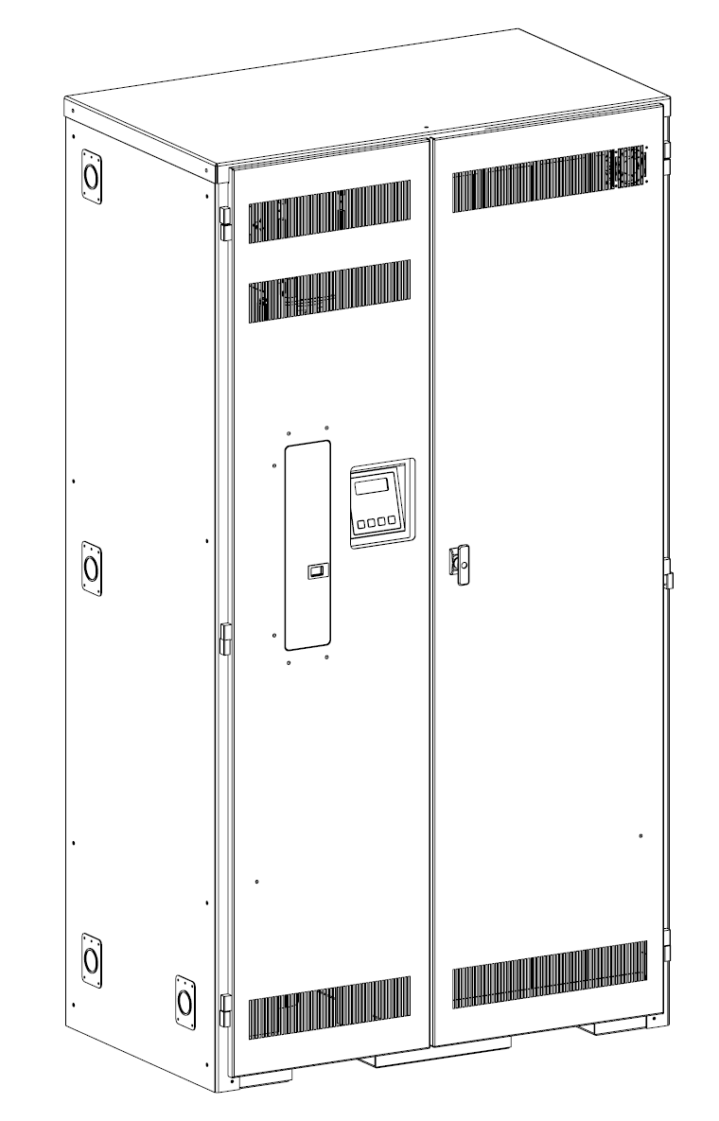
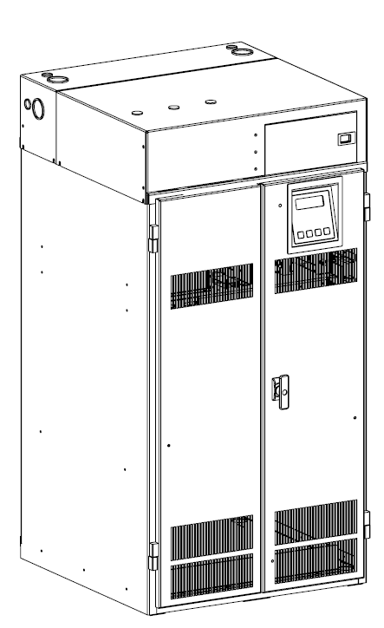
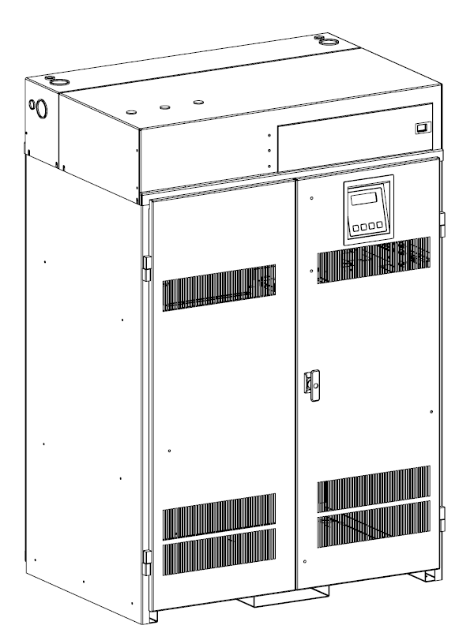

44 South Commerce Way, Bethlehem, PA 18017
1-800-526-5088 • (610) 868-3500 • Fax: (610) 868-8686

Service: (610) 868-5400
www.myerseps.com

C A U T I O N

READ ENTIRE MANUAL AND REVIEW ALL DOCUMENTATION BEFORE ATTEMPTING SYSTEM installation

FOR SERVICE OR INSTALLATION INFORMATION:
TELEPHONE: (610) 868-5400 (24 HR. HOTLINE)
FAX: (610) 954-8227

FOR YOUR PROTECTION
PLEASE COMPLETE AND RETURN WARRANTY REGISTRATION CARD IMMEDIATELY.

This unit contains LETHAL VOLTAGES. All repairs and service should be performed by
AUTHORIZED SERVICE PERSONNEL ONLY! There are NO USER SERVICEABLE PARTS inside this unit.

IMPORTANT SAFEGUARDS

When using electrical equipment, you should always follow basic safety precautions, including the following:

- Read and follow all safety instructions.

- Do not install the system outdoors.

- Do not install near gas or electric heaters or in other high-temperature locations.

- Use caution when servicing batteries. Depending on battery type, batteries contain either acid or alkali and can cause burns to skin and eyes. If battery fluid is spilled on skin or in the eyes, flush with fresh water and contact a physician immediately.

- Equipment should be mounted in locations where unauthorized personnel will not readily subject it to tampering.

- The use of accessory equipment not recommended by Manufacturer may cause an unsafe condition and void the warranty.

- Do not use this equipment for other than its intended use.

- Qualified service personnel must perform all servicing of this equipment.

SAVE THESE INSTRUCTIONS

The installation and use of this product must comply with all national, federal, state, municipal, or local codes that apply. If you need help, please call Service.

User’s Guide
An on-site permanent log of the inspection, testing, and maintenance of the emergency
electrical power supply system shall be maintained in accordance with the
Manufacturer's operating manual. The log shall include:

The date on which the inspection, testing, and maintenance exercise was carried out.

The name of the person(s) who performed the inspection, testing, and maintenance.

A note of any unsatisfactory condition observed or discovered, and the steps taken to
correct the condition.

Table of Contents
C H A P T E R 1 Introduction 5
C H A P T E R 2 Environment 7
C H A P T E R 3 Startup & Shutdown Procedure 8
C H A P T E R 4 Operation 9
C H A P T E R 5 Front Panel Display 10
C H A P T E R 6 Specifications 13
C H A P T E R 7 Options 14
C H A P T E R 8 Maintenance and Service 16

C H A P T E R 1
Introduction

Keep this manual and the System Installation Guide in the folder mounted inside the unit.

This unit is a micro-controller controlled PWM (Pulse Width Modulated) pure sine wave based DC to AC power inverter utilizing IGBT technology. It integrates a fully automatic battery charger, a solid-state transfer system, control circuitry, self testing and recording digital meter display, and maintenance free sealed lead calcium type batteries. The system components are carefully matched to make the unit a completely self-contained, fully automatic standby power source for operation on all types of lighting loads. The batteries are sized and tested per UL-924 and Life Safety Code ANSI / NFPA 101, providing emergency power for a minimum of 90 minutes.

If the duration of a power failure is greater than the batteries storage capability, the inverter will automatically shut down when the battery voltage reaches 85% of the nominal DC voltage. This feature protects the battery from being permanently damaged from a deep discharge that could cause cell reversal. This battery protection feature is called "Low Voltage Disconnect" or L.V.D.

When the AC power is restored after a full discharge, the system will be ready for another power failure within 24hrs. If another power failure occurs before the 24-hour recharge time, the run time will be decreased.

The front panel display incorporates a 4 x 20 vacuum fluorescent display and a 4-button keypad. All user interface functions are available from the front panel assembly.

Utilizing a small footprint, this unit is for use with any lighting load including LED, quartz, HID, incandescent, and fluorescent and halogen.

How to use tHIS mANUAL
This manual tells you how to start, operate, and communicate with your unit and lets you know how to get more information for special situations.
Please record your unit’s model number, serial number, and part number below. You can find these numbers on the label on the inside right-hand door.

Model Number __________________________

Serial Number __________________________

Part Number ___________________________

Service and Support

We are committed to outstanding customer service. A service technician is
available 24 hours a day, 365 days a year. Service is also available 24 hours a day to give you access to technical notes and product information. You can also visit our web site.

NOTE: Please have your unit’s Serial and Model numbers available when you call; this number is located behind the right door.

Contact SERVICE one of the following ways:

Service Number: 610-868-5400

Service Fax: 610-954-8227

Website: www.myerseps.com

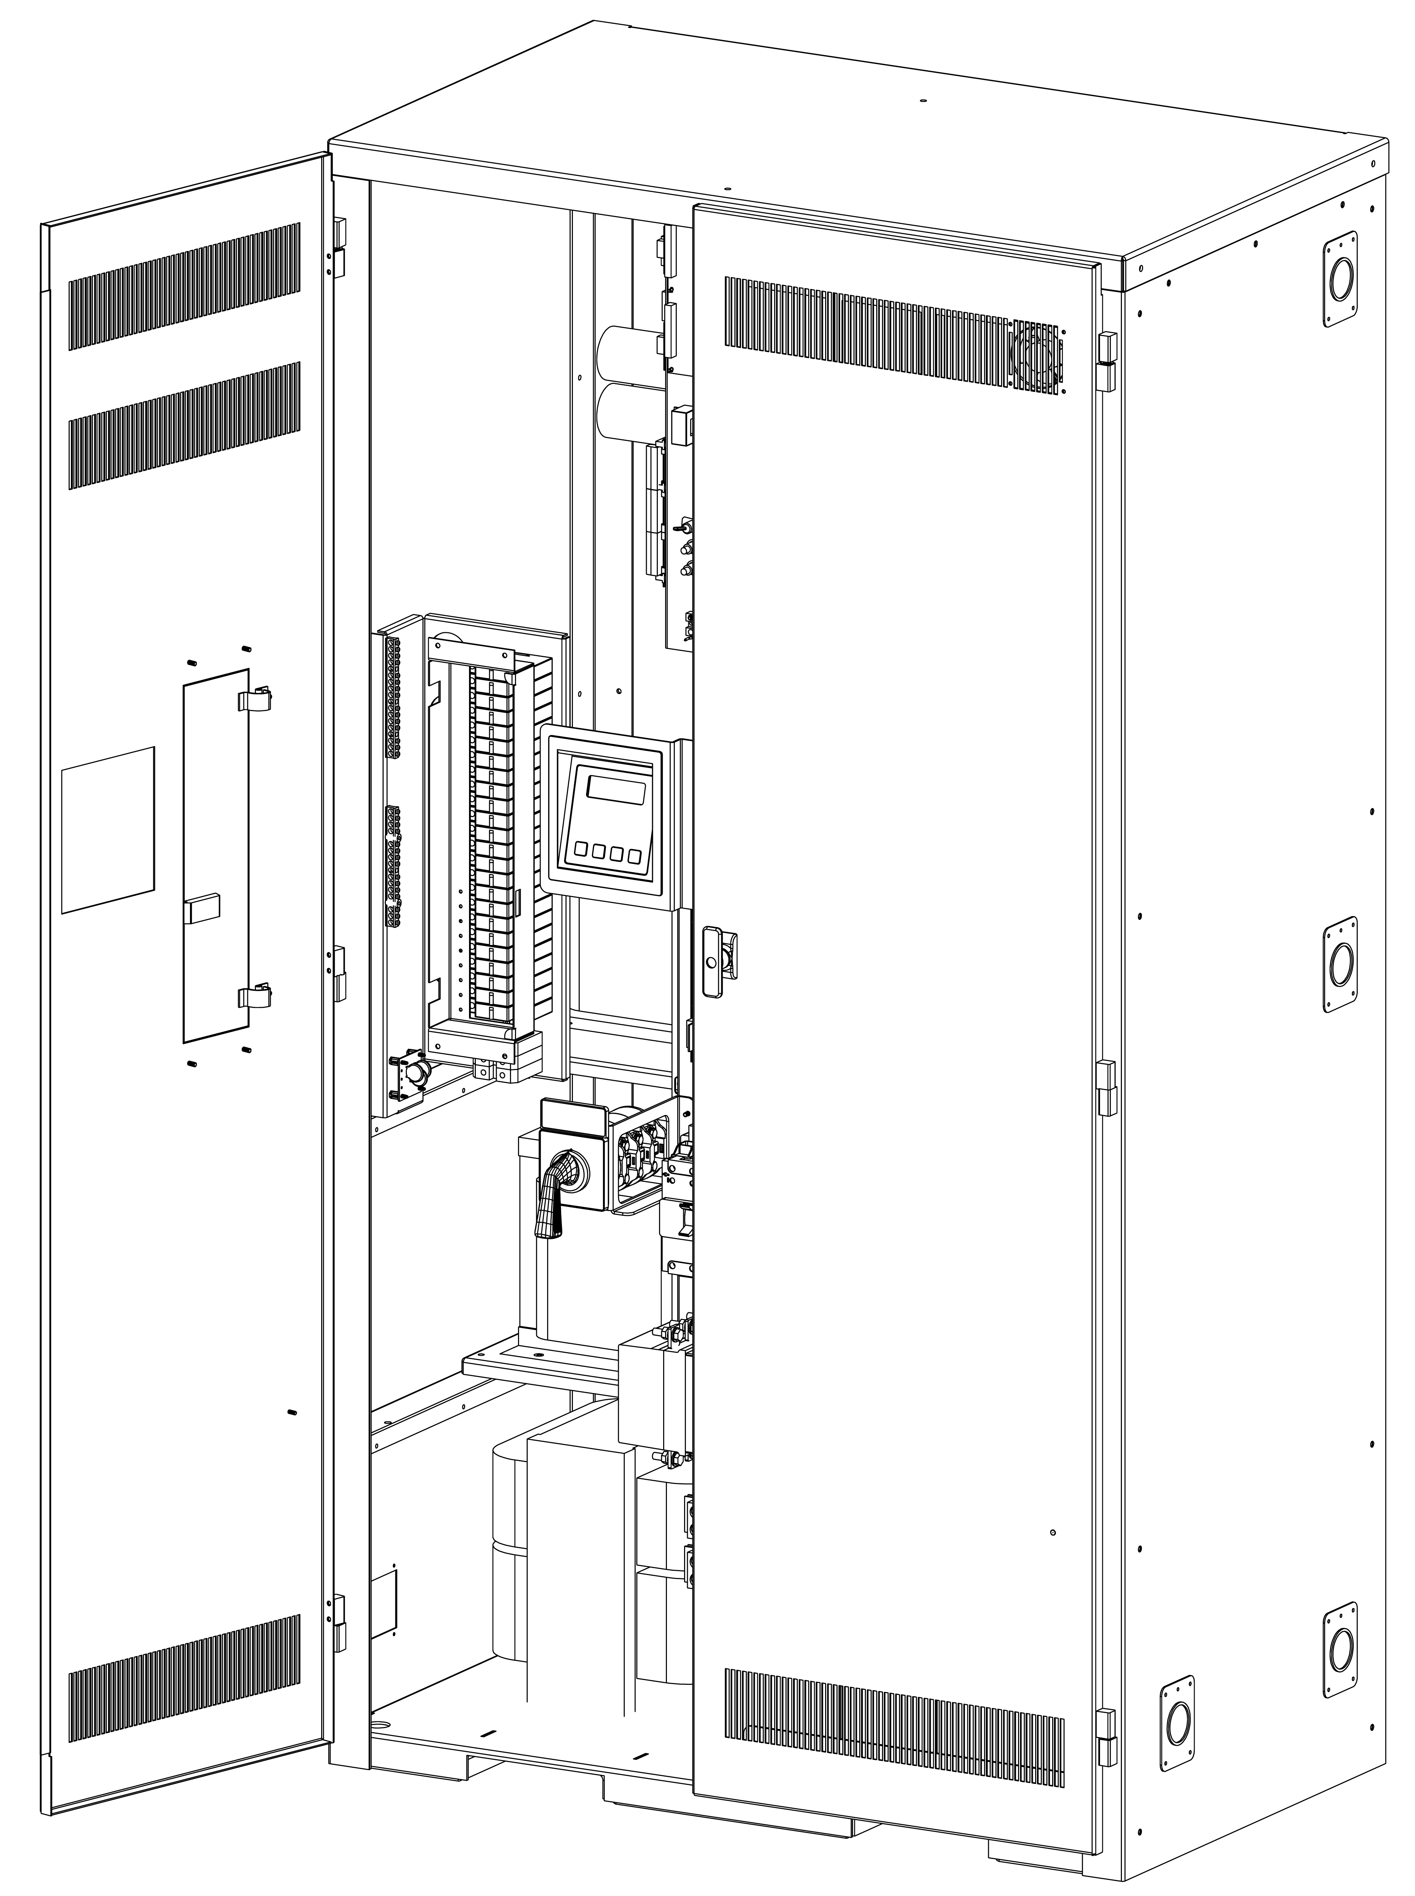

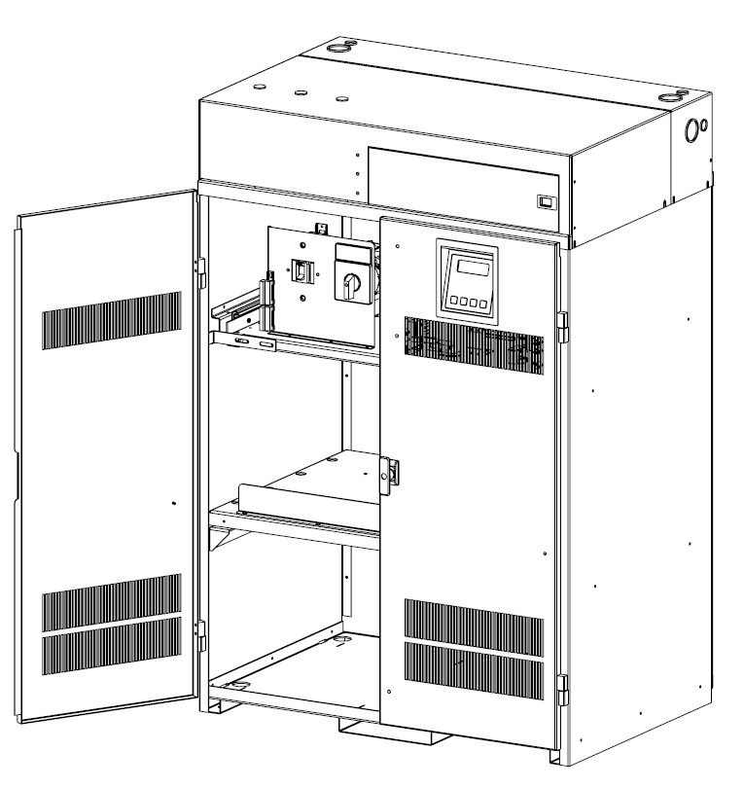
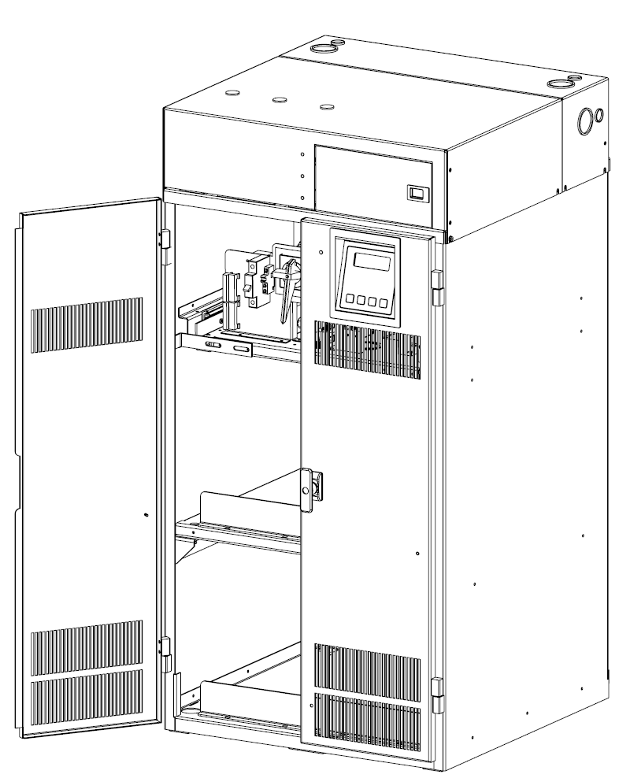

C H A P T E R 2

Environment

Make sure the environment is a clean, cool, dry place with normal ventilation.
Storage Temperature
Store the batteries (in the system or battery cabinet) at -18 to 40°C (0 to 104°F). Batteries have a longer shelf life if they are stored below 25°C (77°F). Keep stored batteries fully charged. Recharge the batteries every 90–120 days. The system or battery cabinet without batteries may be stored at -20 to 70°C (-4 to 158°F).
Ventilation
The air around the unit must be clean, dust-free, and free of corrosive chemicals or other contaminants. Do not place the system or batteries in a sealed room or container.
Operating Temperature
System can operate from 20° to 30°C (68° to 86°F) and up to 95% relative humidity. The batteries’ service life is longer if the operating temperature stays below 25°C (77°F).
Batteries
The temperature should be near 25°C (77°F) for optimum battery performance. Batteries are less efficient at temperatures below 18°C (65°F), and high temperatures reduce battery life. Typically, at about 35°C (95°F), battery life is half of what it would be at a normal temperature of 25°C (77°F). At about 45°C (113°F), battery life is one-fourth of normal.
Make sure that heaters, sunlight, air conditioners, or outside air vents are not directed toward the batteries. These conditions can make the temperature within battery strings vary, which can cause differences in the batteries’ voltages. Eventually, these conditions affect battery performance.
If the batteries are not in the system, remember that the batteries should be installed as close as possible to the unit to reduce DC wiring costs and improve battery performance.
Do not allow tobacco smoking, sparks, or flames in the system location because hydrogen is concentrated under the vent cap of each cell of the battery. Hydrogen is highly explosive, and it is hard to detect because it is colorless, odorless, and lighter than air.
Every type of battery can produce hydrogen gas, even sealed maintenance-free batteries. The gas is vented through the vent caps and into the air, mainly when the unit is charging the batteries. The batteries produce the most hydrogen when maximum voltage is present in fully charged batteries; the batteries do not produce hydrogen during float charging. The amount of current that the charger supplies to the batteries (not the battery ampere-hour) determines how much hydrogen is produced.
High Altitude Operation
Maximum elevation is 3000m (10,000 ft). Derating is 1% per 300m (1000ft) above 3000m (10,000 ft).

C H A P T E R 3

Startup and Shutdown Procedure

Refer to the Installation Manual to secure the unit and install AC and DC wiring.

STARTUP PROCEDURE

For the initial startup of the system, follow the instructions in the Startup and Warranty Validation Form. Failure to do so will void warranty.

CAUTION: HAZARDOUS VOLTAGES – ONLY QUALFIED SERVICE PERSONNEL SHOULD PERFORM PROCEDURE.

1. Verify that the installation switch located on the inverter chassis is in the OFF position. Verify that AC input is disconnected.

2. Press and hold the DC Pre-charge switch located on the inverter chassis for approximately five seconds and then install the battery fuse. If a large flash occurs, the batteries are not connected properly. Call service immediately.

3. Energize the Mains AC input by turning on the units input circuit breaker and/or the Distribution Panel breaker located upstream from the inverter.

4. Turn the installation switch to the on position. The Front Panel display should now be illuminated and a slight hum should be heard from the inverter transformer. The unit is now charging and the output should be energized.

SHUTDOWN PROCEDURE

1. Interrupt the AC Mains to the machine by the Distribution Panel Breaker or the machines input circuit breaker. The Inverter should then start.

2. Turn the installation switch located on the inverter chassis to the off position. The inverter should stop.

3. Open the battery circuit breaker

4. Locate the DC Discharge Switch (S3) and press it for two minutes to discharge Dc capacitors.

5. Using a DC Voltmeter measure the DC voltage across the dc capacitors to ensure the capacitors have been fully discharged.

Note: If a reading of greater than 5 vdc is present repeat step 5.

Caution:
Hazardous voltages still exist at the battery terminal block and within the system. Authorized service technicians must discharge DC capacitors and turn off utility power before servicing equipment.
WARNING:
Do not leave the system shutdown for a prolonged length of time. Lead based batteries will experience permanent damage from lack of charging.

C H A P T E R 4

Operation
The following is a description of the system status located on the front panel of the Vacuum Fluorescent Display.

AC Present

When the AC Mains is present, the words “LINE PRESENT” will illuminate. If a power failure was long in duration, or the AC mains was disconnected by some other means (Circuit breaker open) the “LINE PRESENT” would not be illuminated. When the control circuit senses that the line has dropped below an acceptable level (Black Out, Brown Out, or Transient), the inverter will energize for at least one minute. So, if the power failure was a momentary glitch, the “LINE PRESENT” would be illuminated but the inverter would be running.
System Ready

When the system has adequate battery voltage to transfer, the words “SYSTEM READY” will illuminate.
This feature prevents damage from multiple deep discharges of the battery.
Battery Charging

When the AC Mains is connected to the line and the battery is charging under normal conditions, the words “BATTERY CHARGING” will illuminate.
Battery Power

When the inverter is producing output power (battery is being discharged), the words “BATTERY POWER” will be illuminated.
Fault

This is a summary Fault indication. When there is a fault condition present, the word “FAULT” will illuminate. To view which fault is present, use the keypad and LCD display feature.

The front panel display will provide the user with a variety of information. It has a full compliment of Meter functions, Control functions and Program functions.

CH A P T E R 5
Front Panel Display
The Front Panel Display assembly consists of a 4 x 20 vacuum fluorescent display and a 4-button keypad. The 4 buttons can navigate through all the menus by using the left and right arrow keys, the ENTER and the ESCAPE.
The default menu will scroll between the status screen and the Identification/Date-Time screen. To view the other menu options from the default screen, press the ENTER key, and then press the left or the right arrow key to go to the desired menu.
The Menu’s available are Meter, Test Log, Event Log, Alarm Log, User Setup, Factory Setup, Status, System Information, and Test Mode.
Once the desired menu has been reached, press the ENTER key to gain access to this menu. Once into the menu, use the left or right arrow key to scroll to different functions within the menu. Press the ENTER key again to gain access to the desire function. To exit, press the ESCAPE key until the desired level has been reached. (See figure 5.1)
Figure 5.1 Front Panel Display
Control Panel Keypads
Table 5.1 Keypad Functions
Key Name | Description
Enter (Blue) | Pressing this key will view menus.
Escape (Black) | Pressing this key will exit out of menus and return to the Identification/Date-Time screen.
[ ◄ ] (Red) | This key functions as Left scroll key.
[ ► ] (Red) | This key functions as Right scroll key.
Meter Functions
To get to the meter functions from the default screen, press the ENTER key, scroll to the METER menu using the left or the right arrow key, then press the ENTER key again. Use left or the right arrow key to view the meter function desired.
Table 5.2 Meter Functions
Function | Description
Voltage Input |  | Measures the AC Input Voltage to the Inverter.
Voltage Output |  | Measures the AC Output Voltage from the Inverter.
Current Output |  | Measures the AC Output Current from the Inverter. If there are Normally Off loads connected, it will read the sum of Normally On and Normally Off outputs.
Battery Voltage |  | Measures DC Battery Voltage.
Battery Current |  | Measures the DC Battery Current. When in charge mode, the current will be positive. When in Inverter mode, the current will be negative.
Battery Temperature |  | Optional feature – measures temperature at the battery.
Internal Temperature |  | Measures the ambient temperature inside the system.
Inverter Minutes |  | Indicates the total minutes the system has run on inverter.
System Days |  | Indicates the total days the system has been on-line.
VA Output |  | Indicates the AC Volts-Amps of the Inverter output.
Inverter Watts |  | Indicates the DC Watts (Battery Power) the Inverter is processing.

Test Log

To get to the Test log menu from the default screen, press the ENTER key, scroll to the Test log menu using the left or right arrow key, then press the ENTER key again. Use the left or right arrow key to view the test desired, and the press the ENTER key for more information.
The Test log indicates the Date, Time and Duration of the test. It also indicates if it was a monthly or yearly test, and it records the output voltage, the output current, the ambient temperature, and if there were any alarm conditions.
The numbers of tests that can be captured in the test log are 75. The format is first in is first out so; test number one is the most recent test.

Event Log

To get to the Event log menu from the default screen, press the ENTER key, scroll to the Event log menu using the left or right arrow key, then press the ENTER key again. Use the left or right arrow key to view the event desired, and then press the ENTER key for more information.
The Event log is identical to the test log in parameters it stores. The Event log captures data every time there is a transfer from utility power to battery power. The numbers of events that can be captured in the event log are 75. The format is first in is first out so; event number one is the most recent event.

Alarm Log

To get the Alarm log menu from the default screen, press the ENTER key, scroll to the alarm log menu using the left or right arrow key, then press the ENTER key again. Use the left or right arrow key to view the alarm desired, and then press the ENTER key for more information.
Any alarm that has occurred is captured in the Alarm log. The numbers of alarms that can be captured in the alarm log are 75. The format is first in is first out so; alarm number one is the most recent alarm.

Alarms

To get to the Alarm menu from the default screen, press the ENTER key, scroll the Alarm menu using the left or right arrow key, then press the ENTER key again.
The alarm menu displays all present alarms. If there are no alarms, the display screen will indicate no alarms.

User Setup

To get to the User Setup menu from the default screen, press the ENTER key, scroll to the User Setup menu using the left or right arrow key, then press the ENTER key again. The display will prompt for a password.
**** The password is left arrow, right arrow, left arrow, and right arrow. ****

Once the password is entered, the user has access to change the following functions:
Date, Time, Month Test, Year Test, Low VAC, High VAC, Near Low Battery, Low Battery, High Temp, Load Reduction Current.

Date
The parameters are Day of Week, Month, Day, and Year.
To change any of the parameters, use the left or right arrow key depending if you want to increase or decrease. Once the parameter is correct, press the ENTER key and the next parameter can be changed.

Time
The parameters are Hour and Minute. The 24-hour standard is used so 2:00 PM would be 14 hours. Use the left or right arrow key to change the parameters and the ENTER key to scroll between parameters.

Month Test, Year Test
The parameters are Date, Time (Hours and Minutes) use the left or right arrow key to change the parameters and the ENTER key to scroll between parameters.

Low VAC, High VAC, Near Low Battery, Low Battery, High Temperature
Parameters are set in Volts AC, Volts DC, and Degrees Centigrade respectively.
Use the left or right arrow key to turn on or off this alarm. When the alarm is turned on, a number will appear. To change the number, press the ENTER key and then use the left or right arrow key. Once the desired number is reached, press the ENTER key and this will return to the top-level menu.

Table 5.3 Near Low Battery Fault Chart
 | DC Voltage | Near Low Battery
48VDC |  | 43VDC
72VDC |  | 65VDC
96VDC |  | 86VDC
120VDC |  | 108VDC
144VDC |  | 130VDC
180VDC |  | 162VDC
240VDC |  | 216VDC

Load Reduction Current
Parameters are set in Amps AC.
Use the same technique as the above alarms for modification.
Load Reduction Current is a useful diagnostic tool that will automatically generate a fault when the output current is 10 percent higher or lower than the set-point number.

Status

Indicates the Status of the machine – Line Present, Battery Charging, Ready, Battery Power, and if any faults are present.

System Information

Indicates Model Number, Serial Number and Current Software Revision Level of the system.

Test Mode

To initiate a Test and cause the inverter to run on battery power.

C H A P T E R 6

Specifications
 | Input
 | Voltage | 120 or 277Vac 1-phase 2-wire +10% -20%. Contact factory for all other voltages.
 | Input Frequency | 60Hz, +/- 3%, 50Hz Available upon request
 | Synchronizing Slew Rate | 1Hz per second nominal
 | Protection | Input Circuit Breaker
 | Voltage Harmonic Distortion | < 10% (For Resistive Load)
 | Power Factor | .5 lag/lead
 | Output
 | Voltage | 120 or 277Vac 1-phase 2-wire. Contact factory for all other voltages.
 | Static Voltage | Load current change +/-2%, battery discharge +/-12.5%
 | Dynamic Voltage | +/- 2% for +/-25% load step change, +/-3% for a 50% load step change, recovery within 3 cycles
 | Harmonic Distortion | < 3% THD for linear load
 | Output Frequency | 60Hz +/- .05Hz during emergency mode
 | Load Power Factor | .5 lag to .5 lead
 | Inverter Overload | 115% for 10 minutes, 125% for 15 line cycles
 | Protection | Optional Distribution Circuit Breakers
 | Battery
 | Type | Valve-regulated sealed lead-calcium. Contact factory for additional battery types.
 | Charger | Microcontroller two stage charger (recharge - 24HR)
 | Protection | Automatic low-battery disconnect; automatic restart upon utility return.
 | Disconnect | Fuse
 | Optional Runtimes | Extended runtimes available. Consult factory for additional information.
 | Environmental
 | Altitude | < 10,000 feet (above sea level) without derating
 | Operating Temperature | Inverter: 0°C to 40°C (32°F to 104°F)  Battery: 20°C to 30°C (68°F to 86°F) per UL 924
 | Storage Temperature | -20 to 70 degrees Celsius (electronics only)
 | Relative Humidity | < 95% (non-condensing)
 | General
Design |  | Line interactive PWM inverter type utilizing IGBT technology with 2mS transfer time.
Generator Input |  | Compatible with generators (10x unit size or larger)
Control Panel |  | Microcontroller 4 x 20-charactor vacuum fluorescent display with touch pad controls/functions & scrolling system status
Metering |  | Input & Output Voltage, Battery Voltage, Battery & Output Current, Output VA, Temperature, Inverter Wattage
Alarms |  | High/Low Battery Charger Fault, Near Low Battery, Low Battery, Load Reduction Fault, Output Overload, High/Low AC Input Volts, High Ambient Temperature, Inverter Fault, Output Fault, Optional Circuit Breaker Trip
Communications |  | RS-232 port (DB9)
Manual Maintenance Bypass |  | Optional Internal or optional external without internal distribution breakers.
Alarm Contacts |  | Optional Summary Form "C" Contacts
Warranty |  | 1 year standard warranty includes all parts, labor, & travel expenses within 48 contiguous states. Up to 10 years prorated warranty on batteries. Extended warranties, preventative maintenance and customized service plans are available
Factory Start-up |  | Purchase factory start-up & receive 1 additional year of warranty.
5 Year Service Plan |  | Purchase 5 year service plan & receive free factory start-up.
 | Physical
 | Cabinet | Freestanding NEMA Type 1
 | Cooling | Forced Air, during emergency mode.
 | Cable Entry | Top or Side
 | Access | Front

C H A P T E R 7

Options

MAINTENANCE BYPASS PROCEDURE

CAUTION:
HAZARDOUS VOLTAGES – ONLY QUALFIED SERVICE PERSONNEL SHOULD PERFORM PROCEDURE.

System Into Bypass Mode

- Open System doors. Locate Maintenance Bypass Switch behind left-hand door on chassis.
- Turn Maintenance Bypass Switch handle from normal mode (UPS) (10 O’clock position) to clear mode (*) (12 O’clock position) and push handle in, after engaging handle turn to bypass mode (BYPASS) (2 O’clock position).
- Locate Installation Switch behind right-hand door on chassis. Turn the Installation Switch to the (OFF) position.
- Locate Input Circuit Breaker (CB1) behind left-hand door on chassis. Turn the Input circuit Breaker to the (OFF) position.
- Locate Main Battery Fuse behind right-hand door on chassis. Remove Main Battery fuse.

Caution:
Hazardous voltages still exist at the battery terminal block and within the system. Authorized service technicians must discharge DC capacitors before servicing equipment. Locate discharge switch on inverter chassis. press it for 10 seconds.
warning:
Do not leave the system shutdown for a prolonged length of time. Lead based batteries will experience permanent damage from lack of charging.

Remove all Battery String Fuses from Fuse Holders (10KVA – 16.7KVA Systems).

System On Line From Bypass Mode

- Verify that the Installation Switch located on inverter chassis is in the (OFF) position.
- Install all Battery String Fuses. (10KVA – 16.7KVA Systems)
- Press and hold DC Pre-charge switch located on the inverter chassis for approximately five seconds and then install the Main Battery Fuse on the inverter chassis. If a large flash occurs, the batteries are not connected properly. Call service immediately.
- Turn the Input Circuit Breaker (CB1) to the (ON) position.
- Turn the Installation Switch on the inverter chassis to the (ON) position. The Front Panel Display will now be illuminated and a slight hum should be heard from the inverter transformer. The unit is now charging the batteries.
- Turn the Maintenance Bypass Switch handle from bypass mode (BYPASS) (2 O’clock position) to clear mode (*) (12 O’clock position), then to normal mode (UPS) (10 O’clock position). The emergency equipment is now protected by the inverter system.

C H A P T E R 8

Maintenance And Service

The Self-testing feature of the inverter ensures that the system is tested at least once per month for 5 minutes and once per year for 90 minutes. If there are any problems with the self-tests, the fault log shall indicate which faults occurred. Please see the fault descriptions and troubleshooting guide.

A few simple maintenance operations performed periodically will help ensure many years of trouble free operation. Battery terminals should be checked for tightness and corrosion. If severe corrosion is evident, maintenance is required to correct this situation.

Since the unit depends on unrestricted airflow for cooling of power handling components, it is important to keep the air vents free of any obstruction. If the environment tends to be extremely dusty, occasionally blow away any accumulation of dust on components. Please follow the shutdown procedure before cleaning.

CAUTION: Follow the shutdown procedure (See Chapter 3) before cleaning. An authorized technician only should perform Service!
Table 8.1 Preventive Maintenance Schedule
SERVICE TO PERFORM: | PERFORM SERVICE EVERY:
SERVICE TO PERFORM: | 3 MONTHS | 6 MONTHS | 12 MONTHS
1. TEST UNIT:  NOTE: Perform manual test only when critical load is connected but not required.  ----- Output voltage should be present.  ----- Confirm operations of front panel indicators. | X
2. INSPECT BATTERIES:  ----- All connections are tight.  ----- Connections have no corrosion. (Clean if necessary). |  | X
CLEAN UNIT: NOTE: Unit must be shut down during this service.  ----- Inspect air vents and clean if necessary.  ----- Clean excessive dust from inside cabinet. ----- Clean excessive dust from fan(s). |  |  | X

"X" Indicates when to perform service. Lines below the "X" are for the date of service.
TROUBLE SHOOTING CHART

Battery  Voltage  low  or non  existent |  |  |  |  |  |  |  |  |  | 1 |  | 2 | 3 | 4 | 5
Battery  voltage does  not read  properly  after  Installation  of  fresh  cells |  |  |  |  |  |  |  |  |  |  |  | 4 | 3 |  | 1 | 2
Battery acid  leaking  in  cabinet or  around  tops of  batteries |  |  |  |  |  |  | 1 |  |  |  |  | 2 |  |  | 4 | 3
Batteries  require  continuous  addition  of water to  keep proper level  (optional w/  wet cells) |  |  |  |  |  |  | 3 |  |  |  |  | 1 |  |  | 2 | 4
Charger stays in  HI  charge |  |  |  |  |  |  |  |  |  |  |  | 1 |  |  | 2 | 3
Charger  not charging  properly,  batteries  low or  dead |  |  |  | 2 |  |  |  |  |  |  |  | 6 |  | 3 | 4 | 5 |  | 1
System  blows  battery fuse |  |  | 3 |  | 5 | 6 |  |  | 2 |  | 1 |  |  |  | 4
Inverter  jitters or  staggers  during a  power  failure |  |  | 1 |  | 3 | 2
System  noisy,  transformer  hum  during a  power  failure |  |  |  |  | 1 | 2 |  | 3
System  overheats,  smells,  smokes,  etc. |  |  | 3 |  | 2 | 1 |  |  |  |  |  | 4 |  |  | 6 |  |  | 5
AC output  voltage  low  during a  utility power  failure |  |  | 3 |  | 2 | 1 |  | 4
System  noisy,  excessive  transformer  hum during normal run  conditions |  |  |  |  |  |  |  |  |  |  |  | 1 |  |  | 2 |  |  | 3
System  draws  excessive  AC input  current |  |  |  |  |  | 1 |  | 2 |  |  |  |  |  |  |  |  |  | 3
Inverter  will not  run  during a power failure |  | 1 | 3 |  | 4 | 6 |  |  |  | 2 |  | 11 | 7 | 10 | 9 | 8 | 5
S  Y  M  P  T  O  M  S |  | Installation switch on inverter in off position | Shorted IGBT module(s) | No AC input voltage | Defective inverter | Output volt-ampere rating of unit being exceeded | Ambient temperature too high, vents blocked | Shorted load | Reverse battery diodes shorted | Open battery fuse(s) | Battery polarity wrong | Defective charger | Battery capacity low | Low water in battery  (optional w/ wet cells) | Wrong amount of battery cells in series | Batteries dead, low or defective | Transfer module and/or control circuit malfunction | Transformer not connected for proper voltage
THE NUMBER IN THE CHART INDICATES ORDER IN WHICH PROBLEMS SHOULD  BE CHECKED | PROBLEMS

RETURN MATERIAL AUTHORIZATION (RMA) POLICY

No return material is accepted without written "Return Material Authorization"(RMA). An RMA number is obtainable by contacting the Field Service Department.

Every effort will be made to correct problems over the phone before a RMA is granted or a service trip made. Cooperation will save both time and expense for customer and manufacturer.

If it is deemed necessary to return material, the RMA number must appear on shipping labels, packing slips, and bills of lading.

OUT OF WARRANTY REPAIR CHARGES AND LABOR

Contact Field service for current parts and labor rates. A minimum rate will be assessed. The manufacturer will not proceed with repairs of an out of warranty unit until authorization in the form of a purchase order is received from the customer. The unit for repair must be returned prepaid with an RMA number on the carton. For travel to the job site, a quote "Not to Exceed" estimate will be given. A purchase order to cover that amount is required before a trip to the job site is made.

LIMITED WARRANTY

The parts and on-site labor for the electronics portion of this equipment are warranted against defects in workmanship and material for a period of one year from time of shipment, but in no case will this warranty be valid if installation of equipment is not accomplished within 180 days from date of shipment. Batteries cannot be disconnected from the unit for long periods (180 days) or they will not be able to charge, creating malfunction of both batteries and/or electronics and thereby voiding the warranty. Systems ordered with "Heavy Lead" batteries over 25 Ah have a one year unconditional battery warranty with an additional prorated warranty contingent upon timely return of warranty registration card and the terms called out in the particular battery warranty sheet. See individual battery warranty policy.

The warranty does not cover damage caused by abuse, improper environmental conditions, shipping damage, improper electronics and/or battery installation, unauthorized modifications, service by unauthorized personnel, transportation of damaged equipment, or acts of war. Damage due to lack of maintenance (where applicable) or damage resulting from installation in areas with other than normal temperatures are not covered. See the battery warranty policy for details, as adverse environmental conditions reduce battery life and void the warranty. Replacement of fuses, pilot lamps, and/or contractor labor is not included in warranty. Damage, do to acts of nature, such as, but not limited to, lightning, flooding, explosions and earthquakes, are not covered.

The warranty is limited to the repair and/or replacement of parts and/or units that upon examination at our factory and/or job site are determined to be defective and in our judgment are subject to repair or replacement.
All such repair shall be manufacturer's exclusive remedy. A date code, part number and serial number identify all such units.

TO THE EXTENT ALLOWED BY LAW, MANUFACTURER DISCLAIMS ALL OTHER WARRANTIES, EXPRESS OR IMPLIED, INCLUDING, BUT NOT LIMITED TO, AND LEED WARRANTIES OR MERCHANT ABILITY OR FITNESS FOR A PARTICULAR PURPOSE, AND ANY IMPLIED WARRANTY OF MERCHANT ABILITY OR FITNESS FOR A PARTICULAR PURPOSE ON PRODUCT IS LIMITED IN DURATION TO THE DURATION OF THIS WARRANTY. TO THE EXTENT ALLOWED BY LAW, THE MANUFACTURER SHALL NOT BE LIABLE FOR ANY SPECIAL, INCIDENTAL, OR CONSEQUENTIAL DAMAGES INCLUDING, BUT NOT LIMITED TO, LOSS OF PROFITS, INJURIES TO PROPERTY, LOSS OF USE OF THE PRODUCT OR ANY ASSOCIATED EQUIPMENT.

Special on site extended warranties are also available upon request. The warranty period may be adjusted because of special circumstances, but only by arrangement with the manufacturer at the time of purchase.

All in or out of warranty repaired material or replacement units/parts carry a 90-day new part guarantee. Return of your original repaired component or unit is not guaranteed.

This limited warranty is for the 48 contiguous states.

For international warranty information, call the Field Service Department. See telephone number in front of manual. The standard warranty can be extended and renewed for a nominal fee. Please contact the factory for pricing information.

